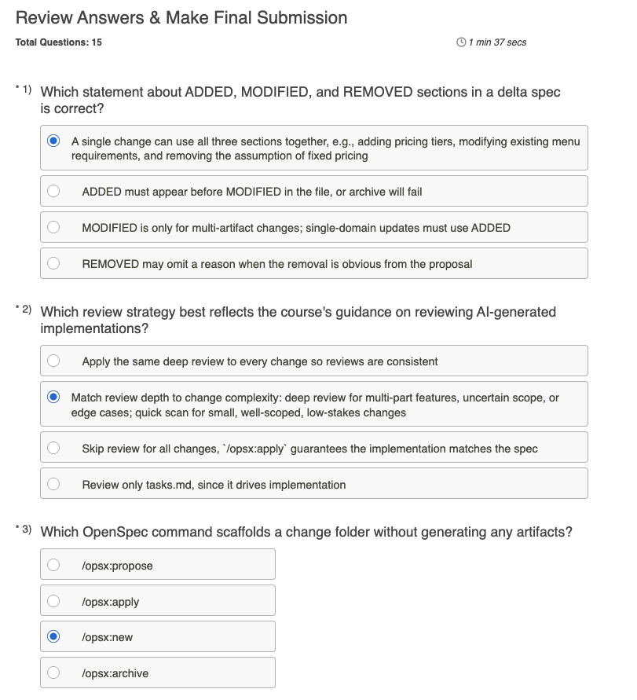

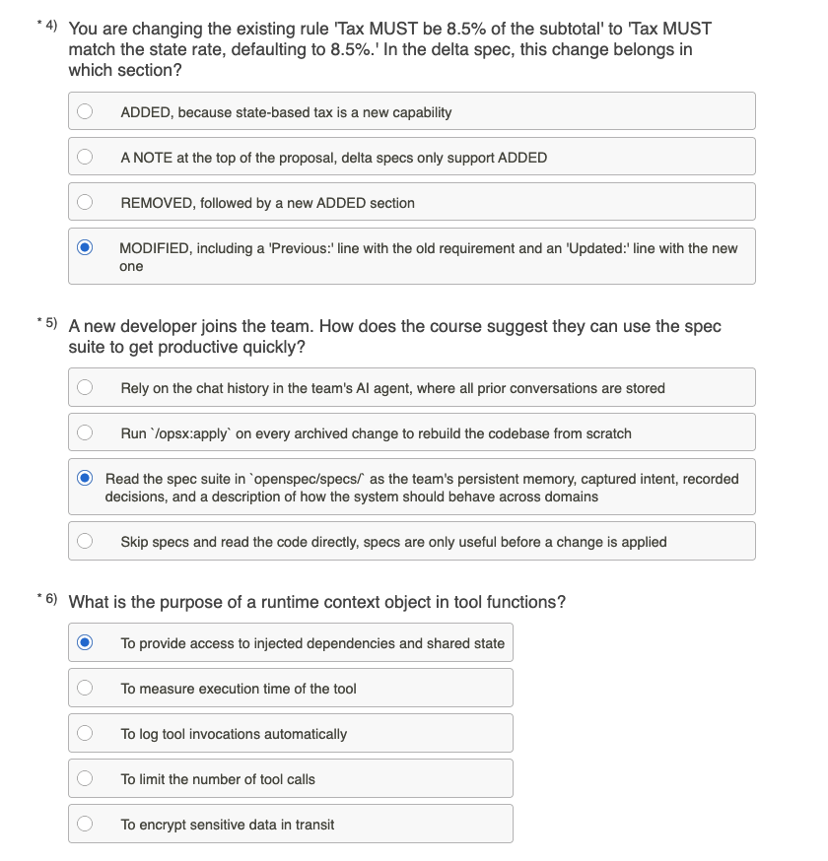

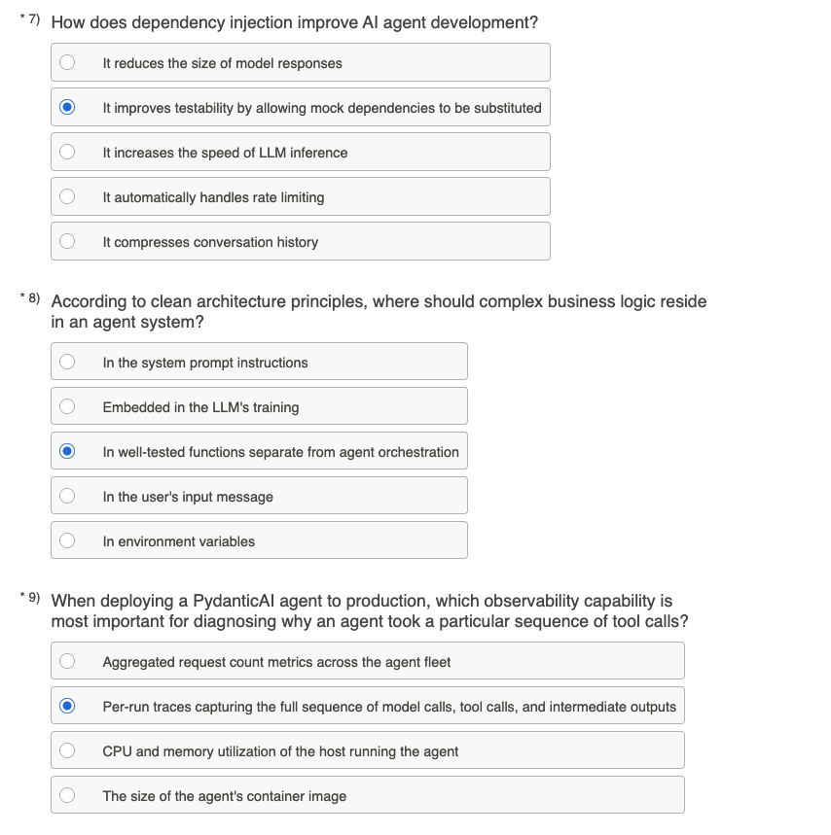

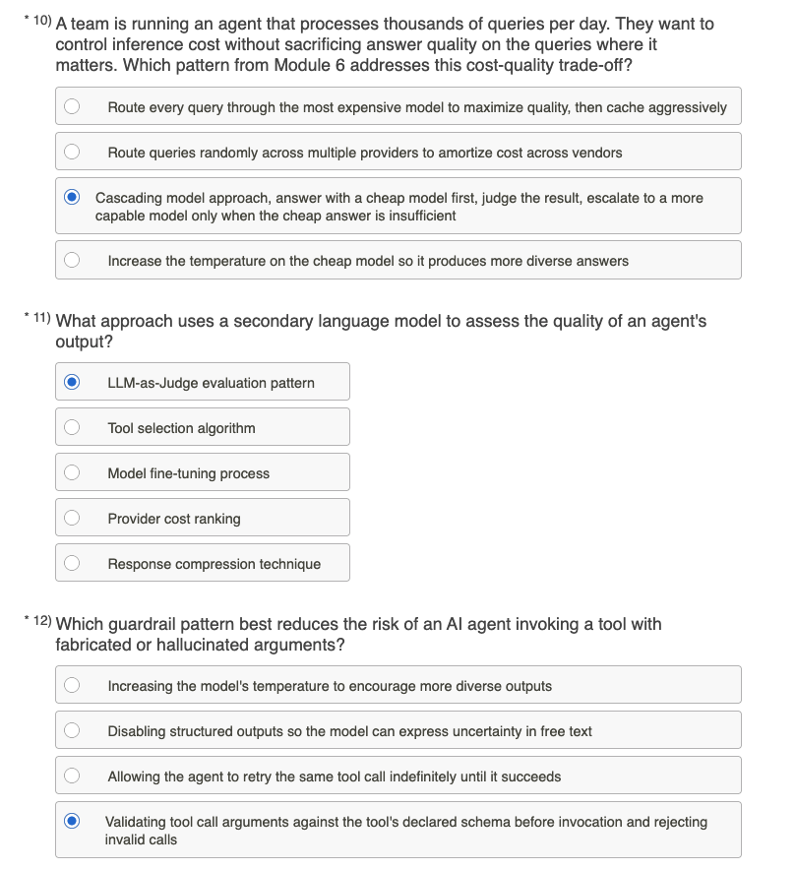

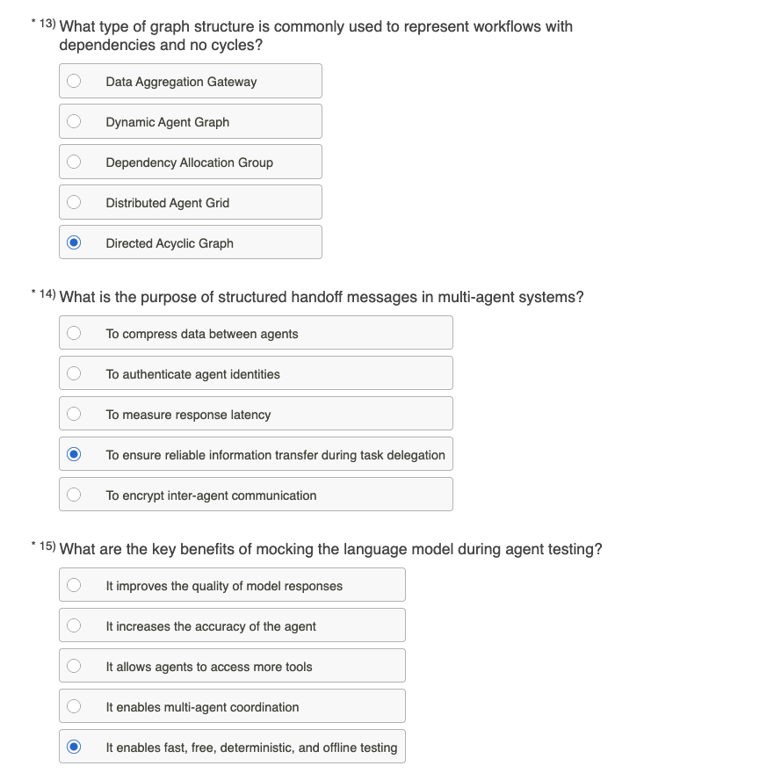

Your Answers

Correct
Points earned: 1 / 1
1)
Which statement about ADDED, MODIFIED, and REMOVED sections in a delta spec is correct?
A single change can use all three sections together, e.g., adding pricing tiers, modifying existing menu requirements, and removing the assumption of fixed pricing (Your Answer)
ADDED must appear before MODIFIED in the file, or archive will fail
MODIFIED is only for multi-artifact changes; single-domain updates must use ADDED
REMOVED may omit a reason when the removal is obvious from the proposal
Feedback
Delta specs routinely combine all three sections in a single change. The dynamic pricing example in AIC-2101 Module 5 does this. MODIFIED applies whenever a prior requirement changes. REMOVED must always include a reason so future developers can distinguish intentional removal from accident. The other options describe rules that don't exist in the OpenSpec delta format.
Correct
Points earned: 1 / 1
2)
Which review strategy best reflects the course's guidance on reviewing AI-generated implementations?
Apply the same deep review to every change so reviews are consistent
Match review depth to change complexity: deep review for multi-part features, uncertain scope, or edge cases; quick scan for small, well-scoped, low-stakes changes (Your Answer)
Skip review for all changes, `/opsx:apply` guarantees the implementation matches the spec
Review only tasks.md, since it drives implementation
Feedback
AIC-2101 teaches that review depth should be proportional to change complexity. Deep review is for multi-part features, uncertain scope, or edge-case-heavy changes. Quick scans suit small, well-scoped, low-stakes ones. Applying identical depth to every change (A) wastes review time on trivial fixes while leaving complex changes under-scrutinized. Skipping review entirely (C) misunderstands /opsx:apply: it implements against the spec but doesn't guarantee the spec was right. Reviewing only tasks.md (D) skips the proposal, specs, and design that contain the actual decisions.
Correct
Points earned: 1 / 1
3)
Which OpenSpec command scaffolds a change folder without generating any artifacts?
/opsx:propose
/opsx:apply
/opsx:new (Your Answer)
/opsx:archive
Feedback
/opsx:new scaffolds the change folder structure (proposal.md, specs/, design.md, tasks.md as empty or templated files) without generating content for any of them. From there, students can use /opsx:continue to generate one artifact at a time with review gates between them (the expanded workflow), or /opsx:ff to generate everything at once (faster but no per-artifact review). /opsx:propose is the lighter core-workflow command that generates all four artifacts in one pass. /opsx:apply runs the implementation against the finalized specs. AIC-2101 Module 4 covers the expanded workflow in detail.
Correct
Points earned: 1 / 1
4)
You are changing the existing rule 'Tax MUST be 8.5% of the subtotal' to 'Tax MUST match the state rate, defaulting to 8.5%.' In the delta spec, this change belongs in which section?
ADDED, because state-based tax is a new capability
A NOTE at the top of the proposal, delta specs only support ADDED
REMOVED, followed by a new ADDED section
MODIFIED, including a 'Previous:' line with the old requirement and an 'Updated:' line with the new one (Your Answer)
Feedback
MODIFIED is the delta section for changes to existing requirements: the requirement still exists, but its content has changed. The 'Previous:' line captures the old wording and the 'Updated:' line captures the new wording. This makes the diff reviewable at the requirement level rather than the file level. ADDED (A) is for genuinely new capabilities; this rule already existed. The NOTE-only approach (B) misframes the delta format. REMOVED + ADDED (C) is overkill for an in-place refinement and loses the connection between old and new. AIC-2101 Module 5 walks through worked examples of ADDED, MODIFIED, and REMOVED.
Correct
Points earned: 1 / 1
5)
A new developer joins the team. How does the course suggest they can use the spec suite to get productive quickly?
Rely on the chat history in the team's AI agent, where all prior conversations are stored
Run `/opsx:apply` on every archived change to rebuild the codebase from scratch
Read the spec suite in `openspec/specs/` as the team's persistent memory, captured intent, recorded decisions, and a description of how the system should behave across domains (Your Answer)
Skip specs and read the code directly, specs are only useful before a change is applied
Feedback
AIC-2101 frames the spec suite in openspec/specs/ as the team's persistent memory: captured intent, recorded decisions, and a behavioral description of the system that survives any single chat session. A new developer reading the spec suite gets oriented to why the system works the way it does, not just how. Chat-history reliance (B) is exactly the failure mode SDD exists to prevent because conversations are ephemeral and don't survive team turnover. /opsx:apply rebuilds (A) misunderstands what apply does. Skipping specs and reading code (D) recovers the how but loses the why, which is what specs uniquely preserve.
Correct
Points earned: 1 / 1
6)
What is the purpose of a runtime context object in tool functions?
To provide access to injected dependencies and shared state (Your Answer)
To measure execution time of the tool
To log tool invocations automatically
To limit the number of tool calls
To encrypt sensitive data in transit
Feedback
The runtime context (RunContext in PydanticAI) gives tools access to injected dependencies and shared state: database connections, API clients, configuration values, all without hard-coding them inside the tool function. This is the foundation of testability. In production, real connections are injected; in tests, mocks are injected via the same mechanism. Execution timing (B), automatic logging (C), call limiting (D), and encryption (E) are all real concerns in agent systems but none are what RunContext is for. GAI-2109 Module 4 covers Dependencies and Runtime Context as a core agent-design concern.
Correct
Points earned: 1 / 1
7)
How does dependency injection improve AI agent development?
It reduces the size of model responses
It improves testability by allowing mock dependencies to be substituted (Your Answer)
It increases the speed of LLM inference
It automatically handles rate limiting
It compresses conversation history
Feedback
Dependency injection's primary benefit is testability. Production code uses real dependencies (databases, APIs); tests substitute mocks or fakes via the same injection mechanism; and the agent code under test doesn't change. This is what enables fast, isolated, deterministic unit tests on agent logic. The other options describe unrelated concerns: response size, inference speed, rate limiting, and conversation history compression are not affected by DI. GAI-2109 Module 4 frames DI as essential for production agents and Module 9 reinforces it as the foundation for testing with TestModel.
Correct
Points earned: 1 / 1
8)
According to clean architecture principles, where should complex business logic reside in an agent system?
In the system prompt instructions
Embedded in the LLM's training
In well-tested functions separate from agent orchestration (Your Answer)
In the user's input message
In environment variables
Feedback
Clean architecture principles place complex business logic in well-tested functions that the agent calls as tools, separate from the agent orchestration code itself. This makes business rules testable without invoking the LLM, debuggable independently, and reusable across agents. Embedding business logic in the system prompt (A) makes it untestable and brittle. Relying on LLM training (B) is non-deterministic and ungovernable. Placing logic in the user message (D) puts it outside team control. Environment variables (E) hold configuration, not logic. GAI-2109 Module 4's 'Separating Business Logic from Agent Logic' section is the explicit teaching.
Correct
Points earned: 1 / 1
9)
When deploying a PydanticAI agent to production, which observability capability is most important for diagnosing why an agent took a particular sequence of tool calls?
Aggregated request count metrics across the agent fleet
Per-run traces capturing the full sequence of model calls, tool calls, and intermediate outputs (Your Answer)
CPU and memory utilization of the host running the agent
The size of the agent's container image
Feedback
Per-run traces (via Logfire or equivalent OpenTelemetry-backed tooling) capture the model calls, tool invocations, and intermediate outputs that together explain what an agent did and why. Aggregate metrics, host resource usage, and image size are useful operationally but do not explain agent decisions. GAI-2109 Module 9 covers Observability and Tracing Integration with structured logging, metrics, and OpenTelemetry.
Correct
Points earned: 1 / 1
10)
A team is running an agent that processes thousands of queries per day. They want to control inference cost without sacrificing answer quality on the queries where it matters. Which pattern from Module 6 addresses this cost-quality trade-off?
Route every query through the most expensive model to maximize quality, then cache aggressively
Route queries randomly across multiple providers to amortize cost across vendors
Cascading model approach, answer with a cheap model first, judge the result, escalate to a more capable model only when the cheap answer is insufficient (Your Answer)
Increase the temperature on the cheap model so it produces more diverse answers
Feedback
The cascading model approach (GAI-2109 Module 6, Cost-Quality Trade-offs) routes queries through a cheap model first, uses an LLM-as-judge to assess the answer, and escalates to a more capable model only when needed. This keeps the per-query cost low for the majority of traffic while preserving quality on the queries that need it. The other options either ignore the trade-off (always-expensive routing), introduce non-determinism without a cost reduction (random vendor routing), or degrade quality (higher temperature).
Correct
Points earned: 1 / 1
11)
What approach uses a secondary language model to assess the quality of an agent's output?
LLM-as-Judge evaluation pattern (Your Answer)
Tool selection algorithm
Model fine-tuning process
Provider cost ranking
Response compression technique
Feedback
LLM-as-Judge uses a secondary language model to evaluate the primary agent's output against quality criteria such as accuracy, relevance, completeness, and tone. The result is a structured judgment that can be logged, aggregated, and used to escalate failing answers to a more capable model. This pattern scales evaluation in a way human review cannot. The other options name unrelated agent concerns: tool selection happens inside the agent loop, fine-tuning is a training-time process, cost ranking is operational metadata, and response compression is a token-economy concern. GAI-2109 Module 6 covers LLM-as-Judge as a core evaluation pattern with a dedicated demo anchor.
Correct
Points earned: 1 / 1
12)
Which guardrail pattern best reduces the risk of an AI agent invoking a tool with fabricated or hallucinated arguments?
Increasing the model's temperature to encourage more diverse outputs
Disabling structured outputs so the model can express uncertainty in free text
Allowing the agent to retry the same tool call indefinitely until it succeeds
Validating tool call arguments against the tool's declared schema before invocation and rejecting invalid calls (Your Answer)
Feedback
Schema validation at the tool boundary is a core PydanticAI pattern. Tool arguments are typed and validated before the tool executes, catching hallucinated or malformed arguments before they cause harm. Higher temperature increases hallucination risk. Indefinite retries waste budget without addressing the cause. Disabling structured outputs removes the validation guarantee. GAI-2109 Module 6 covers Input and Output Guardrails as the layer that enforces this.
Correct
Points earned: 1 / 1
13)
What type of graph structure is commonly used to represent workflows with dependencies and no cycles?
Data Aggregation Gateway
Dynamic Agent Graph
Dependency Allocation Group
Distributed Agent Grid
Directed Acyclic Graph (Your Answer)
Feedback
A Directed Acyclic Graph (DAG) represents workflows where steps have explicit dependencies but the graph never loops back on itself. The 'directed' part captures dependency direction (step B depends on step A). The 'acyclic' part guarantees the workflow terminates and can be topologically sorted into a valid execution order. Python's graphlib.TopologicalSorter is the standard library tool for this. GAI-2109 Module 7's demo anchor uses it explicitly, including showing graphlib.CycleError fire when a student deliberately introduces a cycle. The other options are plausible-sounding but made-up terms.
Correct
Points earned: 1 / 1
14)
What is the purpose of structured handoff messages in multi-agent systems?
To compress data between agents
To authenticate agent identities
To measure response latency
To ensure reliable information transfer during task delegation (Your Answer)
To encrypt inter-agent communication
Feedback
Structured handoff messages use well-defined schemas (typically Pydantic models) so that when one agent delegates work to another, the receiving agent gets every field it needs in the expected shape. There is no context loss, no ambiguous prose to re-parse, and no missing fields silently defaulted. This is what makes multi-agent coordination reliable instead of fragile. Compression (A), authentication (B), latency measurement (C), and encryption (E) are all real concerns in distributed systems but none are what 'structured handoff' refers to. GAI-2109 Module 8 covers Coordination and Handoff Protocols including the Structured Handoff, Request-Response, and Broadcasting patterns.
Correct
Points earned: 1 / 1
15)
What are the key benefits of mocking the language model during agent testing?
It improves the quality of model responses
It increases the accuracy of the agent
It allows agents to access more tools
It enables multi-agent coordination
It enables fast, free, deterministic, and offline testing (Your Answer)
Feedback
PydanticAI's TestModel lets tests exercise agent logic without calling a real LLM. That means tests are fast (no network round-trips), free (no API costs), deterministic (same input always produces same output, unlike real LLMs), and runnable offline (no API key needed). This makes agent code testable the same way any other Python code is testable. Mocking doesn't improve real response quality (A) or accuracy (B); it sidesteps them. Tool access (C) and multi-agent coordination (D) are orthogonal concerns. GAI-2109 Module 9's TestModel demo anchor lands exactly this 'fast, free, deterministic, offline' framing as the foundational testing pattern.

